**Name: Qadeer Hussain**

**Class:BS**

**Department: Computer Science**

**Section:C**

**Roll No: 14**

**Semester: 4th**

**Subject: Design and Analysis of Algorithms**

**QUESTION NO:1**

1. **For each of the following problems answer True or False and BRIEFLY JUSTIFY you answer. (2 Marks)**

**Suppose O(1) time complexity, then the runtime of the code is exactly the same for all possible inputs.**

**Ans:** False,because O(1) An algorithm is said to run in constant time if it requires the same amount of time regardless of the input size.

1. **O(n^2 log n) is faster than O(n^2.1).**

**Ans:** True,Because O(n^2 log n) is much closer to O(n) than to O(n^2.1) .

**QUESTION NO:2**

1. **List the following functions by increasing growth rate. If two functions have the same growth rate, state that fact. No justification is needed. (2 Marks)**

**O(log n) O(1.1n) O(n log n) O(n (log n)^2) O(3 log n) O(2^5) O(n^34)**

**Ans:**O(2^5) O(log n) O(n log n) O(3 log n) O(n(log n)^2) O(n^34) O(1.1n)

**QUESTION NO:3**

1. **What is the time complexity of following code: (4 Marks each)**
2. **int function(int n)**

**{**

**int c = 0;**

**for (i = 0; i <=n; i++)**

**for (j = i; j>=0; j--)**

**c = c + 1;**

**return c;**

**}**

**Ans:**O(n*n)

1. **int i, j, k = 0;**

**for (i = n / 2; i <= n; i++)**

**{**

**for (j = 2; j <= n; j = j * 2)**

**{**

**k = k + n / 2;**

**}**

**}**

**Ans:** O(n log n)

1. **void function(int n)**

**{**

**int c = 0;**

**for (i=n/2; i<=n; i++)**

**for (int j=1; j<=n; j = 2 * j)**

**for (int k=1; k<=n; k = k * 2)**

**c++;**

**}**

**Ans:**O(n log n)

1. **void function(int n)**

**{**

**int c = 0;**

**for (i=n/2; i<=n; i++)**

**for (j=1; j+n/2<=n; j = j++)**

**for (k=1; k<=n; k = k * 2)**

**c++;**

**}**

**Ans:** O(n^2 log n)

**QUESTION NO:4**

1. **Create a Min heap and then delete the Min value from it. Show your result in the form of tree and array.**

**0 1 2 3 4 5 6 7 8 9 10 11 12 13**

**- Z W Y T G K V R S F A - -**

**Ans:**

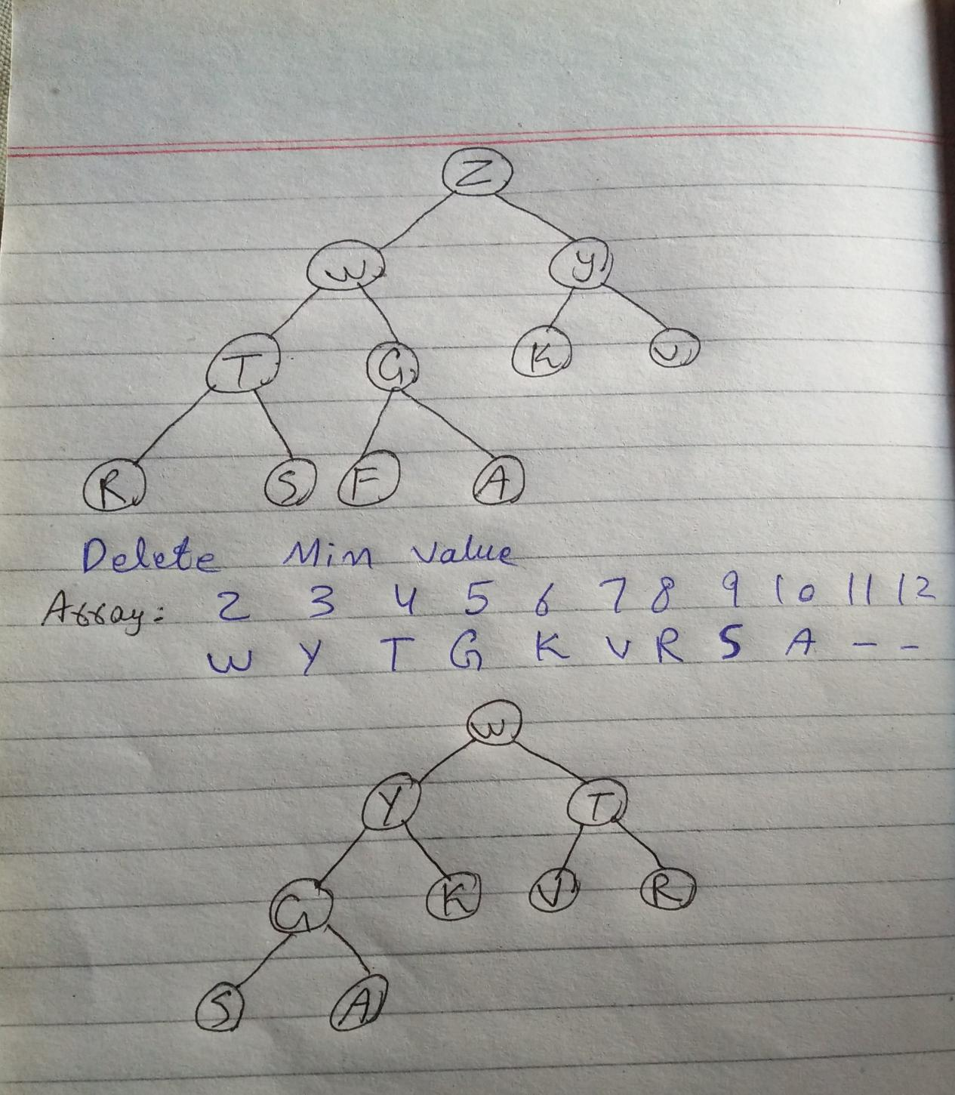

**QUESTION NO:5**

1. **Create a binary SEARCH tree and apply these operations:**

**Values are 23, 67,8,97,21,34,6,3,1,9,45,8,38,54,12,19,84**

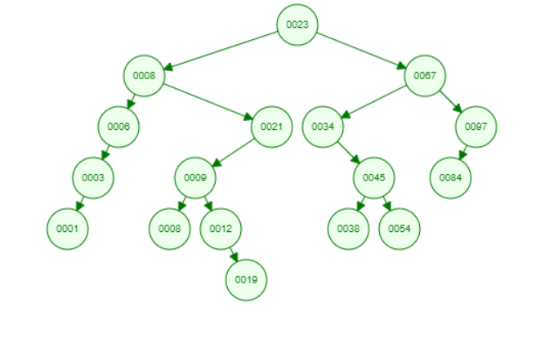

1. **Delete 9**

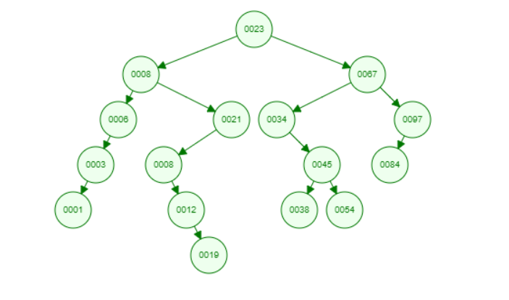

**b) Add 18**

